Please provide me with the following for the Client Letter:
- Your ID at Client Site (if known): wei.liu@nscorp.com
- Copy of Your Badge at Client (if applicable):
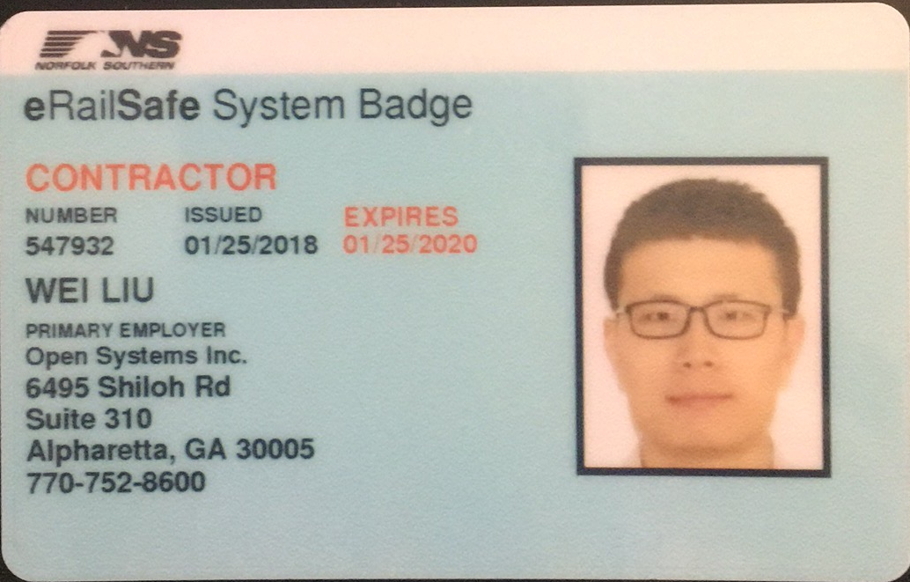
- Your Full Legal Name: Wei Liu
- Country of Birth: China
- Client Name: Norfork Southern Railway
- Client Work Location Address: 1200 Peachtree St NE, Atlanta, GA, USA, 30309
- Client Department: Information Technology
- Project Title (if applicable):
- Your Title at Client: Data Scientist
- Please provide the top five main responsibilities for your role. Each responsibility should be kept to a maximum of two sentences per item.
- Collaborate with product management and engineering departments to understand company needs and devise possible solutions
- Mine and analyze data from big-data databases, perform data cleansing and engineering.
- Analyze the requirements from business partners, develop custom machine learning models and algorithms to apply to big-data sets.
- Use predictive models to provide actionable insights to the business partners.
- Develop A/B testing framework and test model quality, analyze and optimize the model outcomes.
- Your Current Pay Rate: 45$/h
- Client Manager Name: Amouie Mabby
- Client Manager Title: Senior Manager Advanced Analytics
- Client Manager Email Address: Mabby.Amouie@nscorp.com

